Social Reform in the Gilded and Progressive Eras
Student’s Name
Institution
Date

Social Reform in the Gilded and Progressive Eras
Question One
Women’s rights in the late 19th century was caused by the alarming call by suffragist leaders such as Elizabeth Cady Stanton and Susan B. Anthony to ensure that women had equal rights like men to enjoy the right to vote and have access to education as well as employment (Miller, 2020). Immigration reform was propagated by the increased migration of people into America due to high economic opportunities within it.
Question Two
Proponents of women’s rights were Elizabeth Cady Stanton and Susan B. Anthony, suffragist leaders who advocated for the rights of women. They championed for the right of women to vote and have access to employment and education like men. Thomas J. Geary was the proponent of the immigration reform as he proposed Geary Act of 1892 that ensured that the influx of Chinese immigrants into America was maintained.
Question Three
Women rights to vote was passed by Congress in June 4, 1919 and became ratified on August 18, 1920. The reform granted women the right to participate in voting. Likewise, the immigration reform was enacted through legislation by Congress in the House (González, 2020). The reform underwent numerous deliberations to ensure that illegal immigrants were prevented from entering America. For instance, the Chinese Exclusion Act had the purpose of curbing the migration of Chinese immigrants into America.
A Photograph by Riis showing portraying struggle for women’s rights
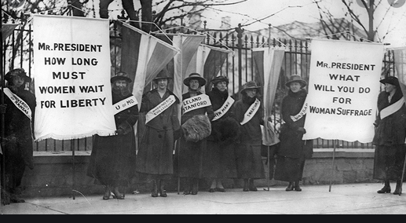
http://www.americanyawp.com/text/wp-content/uploads/Womens-Suffrage1.jpg
A Photograph by Riis showing barred immigrants
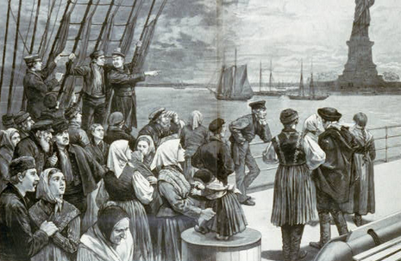
http://www.citizenship-aei.org/2013/04/americas-patriotic-assimilation-system-is-broken/#.X6UhllBRXIU

References
González, F. (2020). Immigration and human capital: consequences of a nineteenth century settlement policy. Cliometrica, 14(3), 443-477.
Miller, C. (2020). Women's Suffrage: Voting Rights in Cache County, Utah 1870-1965.

